Congruence Transformation

Definition
# Source: AI Source: Provided by: [Data Path: Persons Table -> ID Column: 1, Name_En Column: Motasem Essam] -> From: [ChatGPT] on [7/25/2026]
A Congruence Transformation is a geometric transformation that maps a figure to another figure of the same shape and same size.
It preserves all distances and angle measures between corresponding points.
Therefore, if a figure $S$is transformed into $S^{'}$:
$$\boxed{S≅S^{'}}$$
A congruence transformation is also called an isometry.

Fundamental Concept
# Source: AI Source: Provided by: [Data Path: Persons Table -> ID Column: 1, Name_En Column: Motasem Essam] -> From: [ChatGPT] on [7/25/2026]
The central idea is:
A congruence transformation changes the position or orientation of a figure without changing its size or shape.
For example, a triangle can be:
- moved to another location,
- rotated,
- reflected,
- or moved through a combination of these transformations,
while remaining congruent to the original triangle.
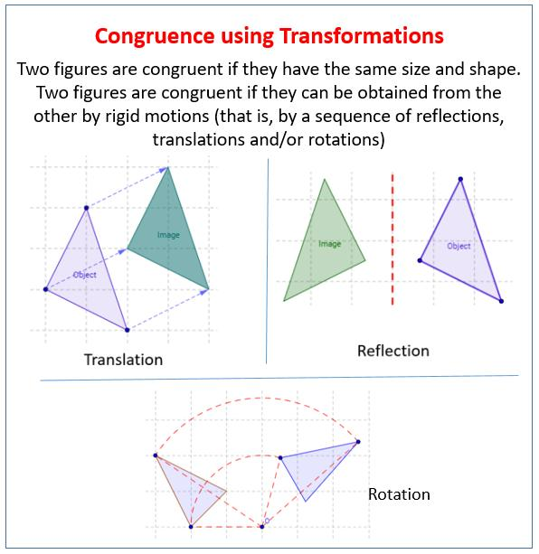
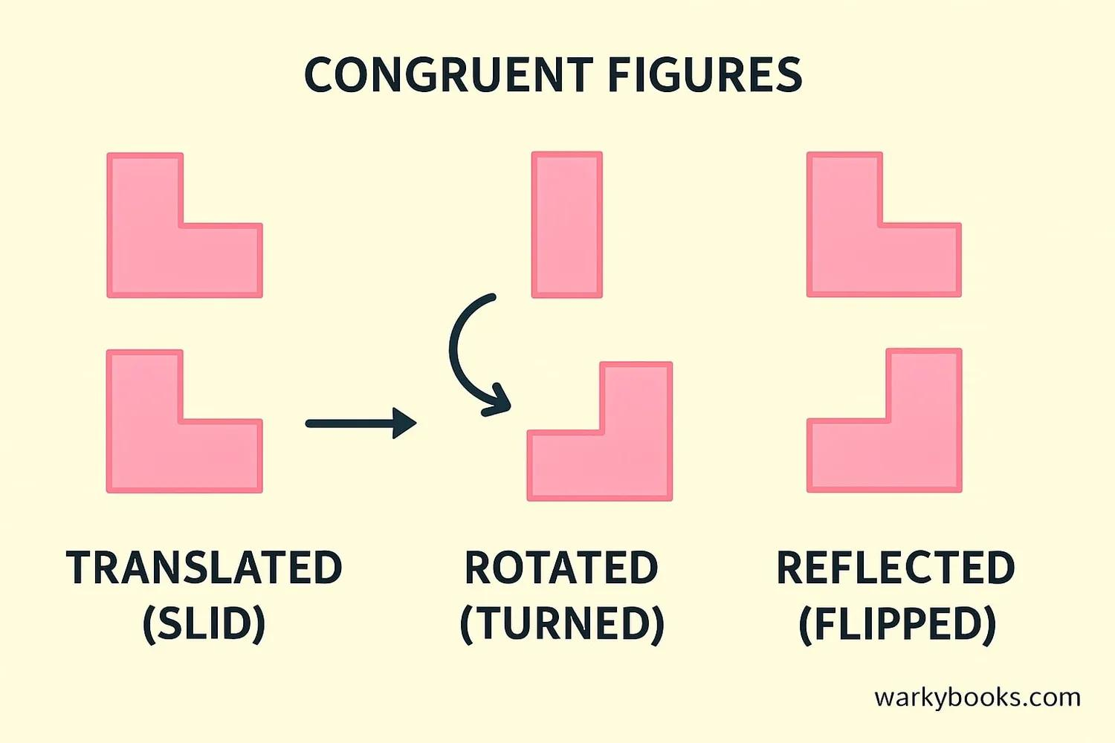
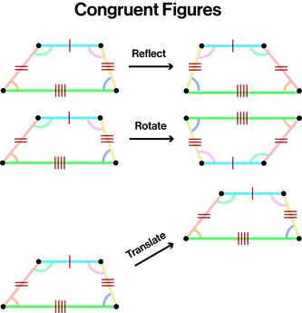
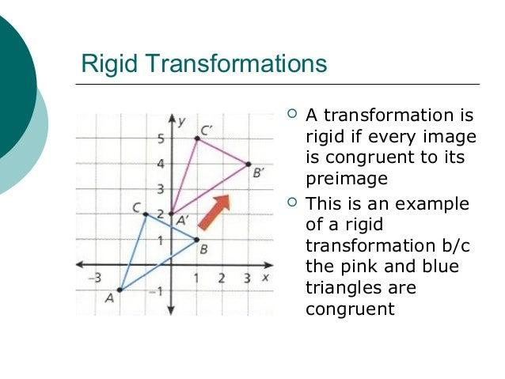
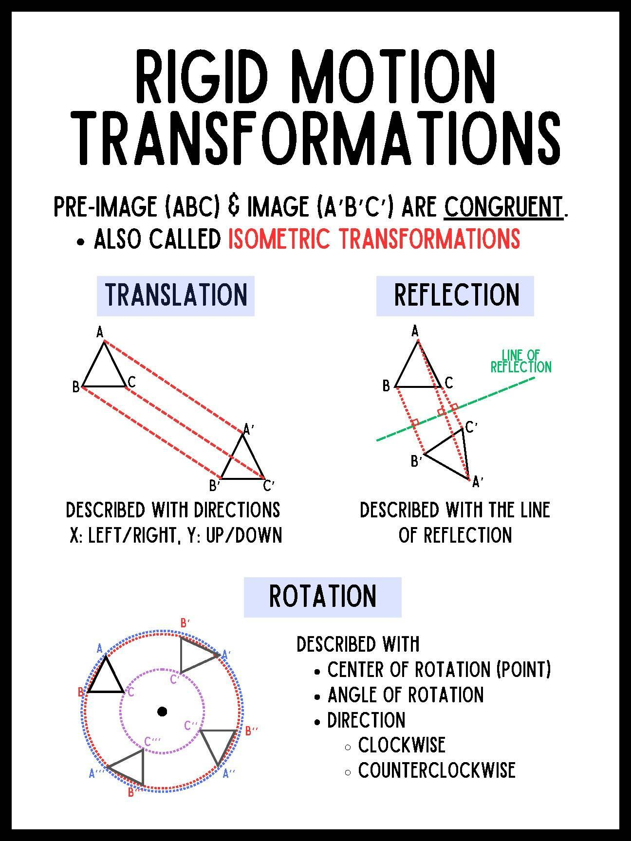

Basic Structure
# Source: AI Source: Provided by: [Data Path: Persons Table -> ID Column: 1, Name_En Column: Motasem Essam] -> From: [ChatGPT] on [7/25/2026]
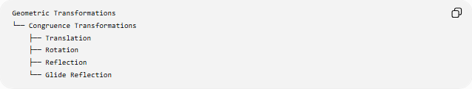
Geometric Transformations
└── Congruence Transformations
├── Translation
├── Rotation
├── Reflection
└── Glide Reflection
These are the four fundamental rigid transformations of the plane.

Main Characteristics
# Source: AI Source: Provided by: [Data Path: Persons Table -> ID Column: 1, Name_En Column: Motasem Essam] -> From: [ChatGPT] on [7/25/2026]
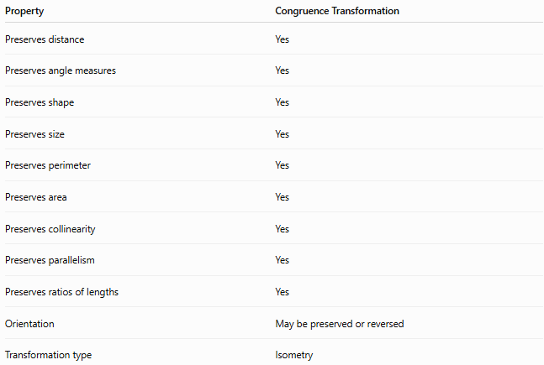
Property | Congruence Transformation
Preserves distance | Yes
Preserves angle measures | Yes
Preserves shape | Yes
Preserves size | Yes
Preserves perimeter | Yes
Preserves area | Yes
Preserves collinearity | Yes
Preserves parallelism | Yes
Preserves ratios of lengths | Yes
Orientation | May be preserved or reversed
Transformation type | Isometry

Distance Preservation
# Source: AI Source: Provided by: [Data Path: Persons Table -> ID Column: 1, Name_En Column: Motasem Essam] -> From: [ChatGPT] on [7/25/2026]
The defining mathematical property is preservation of distance.
For any two points $P$and $Q$:
$$\boxed{PQ=P^{'}Q^{'}}$$
where $P^{'}$and $Q^{'}$are their images.
More generally:
$$\boxed{d\left(T , \left(P\right)T\left(Q\right)\right)=d\left(P , Q\right)}$$
where $T$is the congruence transformation.

Angle Preservation
# Source: AI Source: Provided by: [Data Path: Persons Table -> ID Column: 1, Name_En Column: Motasem Essam] -> From: [ChatGPT] on [7/25/2026]
Congruence transformations preserve angle measures.
If:
$$∠ABC=θ$$
then after transformation:
$$\boxed{∠A^{'}B^{'}C^{'}=θ}$$
Therefore, corresponding angles remain equal.

Shape and Size
# Source: AI Source: Provided by: [Data Path: Persons Table -> ID Column: 1, Name_En Column: Motasem Essam] -> From: [ChatGPT] on [7/25/2026]
A congruence transformation does not stretch or shrink a figure.
Therefore:
$$\boxed{\text{Shape preserved}}$$
and
$$\boxed{\text{Size preserved}}$$
For example, if a triangle has side lengths:
$$3, 4, 5$$
its image must also have corresponding side lengths:
$$3, 4, 5$$

Types of Congruence Transformations

1-Translation
# Source: AI Source: Provided by: [Data Path: Persons Table -> ID Column: 1, Name_En Column: Motasem Essam] -> From: [ChatGPT] on [7/25/2026]
A translation moves every point of a figure by the same distance and in the same direction.
$$\boxed{\left(x , y\right)→\left(x , +ay+b\right)}$$
Example:
$$\left(x , y\right)→\left(x , +4y+2\right)$$
moves every point 4 units right and 2 units up.
Translation
Figure ─────────────→ Image

2-Rotation
# Source: AI Source: Provided by: [Data Path: Persons Table -> ID Column: 1, Name_En Column: Motasem Essam] -> From: [ChatGPT] on [7/25/2026]
A rotation turns a figure around a fixed point called the center of rotation.
For rotation about the origin:
$$\boxed{x^{'}=x\cos{θ}-y\sin{θ}} \\ \boxed{y^{'}=x\sin{θ}+y\cos{θ}}$$
Examples include:
- ${90}^{∘}$rotation
- ${180}^{∘}$rotation
- ${270}^{∘}$rotation
The distance from every point to the center of rotation remains unchanged.

3-Reflection
# Source: AI Source: Provided by: [Data Path: Persons Table -> ID Column: 1, Name_En Column: Motasem Essam] -> From: [ChatGPT] on [7/25/2026]
A reflection flips a figure across a line called the line of reflection.
For reflection across the $x$-axis:
$$\boxed{\left(x , y\right)→\left(x , -y\right)}$$
For reflection across the $y$-axis:
$$\boxed{\left(x , y\right)→\left(- , xy\right)}$$
Reflection preserves size and shape but reverses orientation.

4-Glide Reflection
# Source: AI Source: Provided by: [Data Path: Persons Table -> ID Column: 1, Name_En Column: Motasem Essam] -> From: [ChatGPT] on [7/25/2026]
A glide reflection combines:
- a reflection, and
- a translation parallel to the reflection line.
$$\boxed{G=T_{\vec{v}}∘R_{l}}$$
where:
$$\vec{v}∥l$$
For example, reflection across the $x$-axis followed by a translation $d$units to the right gives:
$$\boxed{\left(x , y\right)→\left(x , +d-y\right)}$$

Classification
# Source: AI Source: Provided by: [Data Path: Persons Table -> ID Column: 1, Name_En Column: Motasem Essam] -> From: [ChatGPT] on [7/25/2026]
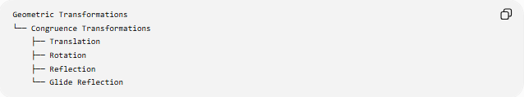
Geometric Transformations
└── Congruence Transformations
├── Translation
├── Rotation
├── Reflection
└── Glide Reflection
These can also be classified according to orientation:
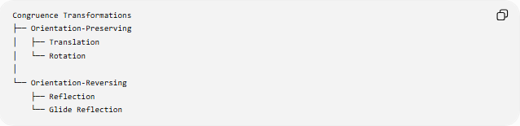
Congruence Transformations
├── Orientation-Preserving
│ ├── Translation
│ └── Rotation
│
└── Orientation-Reversing
├── Reflection
└── Glide Reflection
This distinction is important:
- Translation and rotation preserve orientation.
- Reflection and glide reflection reverse orientation.

Congruence Transformation and Isometry
# Source: AI Source: Provided by: [Data Path: Persons Table -> ID Column: 1, Name_En Column: Motasem Essam] -> From: [ChatGPT] on [7/25/2026]
The terms congruence transformation and isometry are closely related.
An isometry is a transformation that preserves distances.
$$d\left(T , \left(P\right)T\left(Q\right)\right)=d\left(P , Q\right)$$
Therefore:
$$\boxed{\text{Congruence Transformation}=\text{Isometry}}$$
in the usual Euclidean-plane context.

Congruent Figures
# Source: AI Source: Provided by: [Data Path: Persons Table -> ID Column: 1, Name_En Column: Motasem Essam] -> From: [ChatGPT] on [7/25/2026]
Two figures are congruent if one can be mapped onto the other by a congruence transformation.
$$\boxed{A≅B}$$
For example:
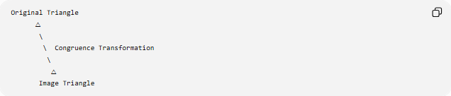
Original Triangle
△
\
\ Congruence Transformation
\
△
Image Triangle
The two triangles have:
- equal corresponding side lengths,
- equal corresponding angles,
- the same shape,
- the same size.

Example
# Source: AI Source: Provided by: [Data Path: Persons Table -> ID Column: 1, Name_En Column: Motasem Essam] -> From: [ChatGPT] on [7/25/2026]
Consider a triangle:
$$A\left(1 , 1\right), B\left(4 , 1\right), C\left(1 , 3\right)$$
Translate it by:
$$\left(x , y\right)→\left(x , +5y+2\right)$$
The image is:
$$A^{'}\left(6 , 3\right) \\ B^{'}\left(9 , 3\right) \\ C^{'}\left(6 , 5\right)$$
Original side lengths:
$$AB=3 \\ AC=2 \\ BC=\sqrt{13}$$
Image side lengths:
$$A^{'}B^{'}=3 \\ A^{'}C^{'}=2 \\ B^{'}C^{'}=\sqrt{13}$$
Thus:
$$\boxed{△ABC≅△A^{'}B^{'}C^{'}}$$

Area Preservation
# Source: AI Source: Provided by: [Data Path: Persons Table -> ID Column: 1, Name_En Column: Motasem Essam] -> From: [ChatGPT] on [7/25/2026]
Because a congruence transformation preserves distances and shape, it also preserves area.
$$\boxed{A^{'}=A}$$
For example, if a triangle has area:
$$A=12{\text{ cm}}^{2}$$
its image also has:
$$\boxed{A^{'}=12{\text{ cm}}^{2}}$$

Perimeter Preservation
# Source: AI Source: Provided by: [Data Path: Persons Table -> ID Column: 1, Name_En Column: Motasem Essam] -> From: [ChatGPT] on [7/25/2026]
All corresponding side lengths remain unchanged.
Therefore:
$$\boxed{P^{'}=P}$$
If the original perimeter is $20$cm, the transformed figure also has perimeter $20$cm.

What Congruence Transformations Do Not Do
# Source: AI Source: Provided by: [Data Path: Persons Table -> ID Column: 1, Name_En Column: Motasem Essam] -> From: [ChatGPT] on [7/25/2026]
A congruence transformation does not:
- enlarge a figure,
- shrink a figure,
- stretch a figure,
- compress a figure,
- change an angle measure,
- change a side length.
For example, a transformation such as
$$\left(x , y\right)→\left(2 , x2y\right)$$
is not a congruence transformation because distances are doubled.

Congruence vs Similarity
# Source: AI Source: Provided by: [Data Path: Persons Table -> ID Column: 1, Name_En Column: Motasem Essam] -> From: [ChatGPT] on [7/25/2026]
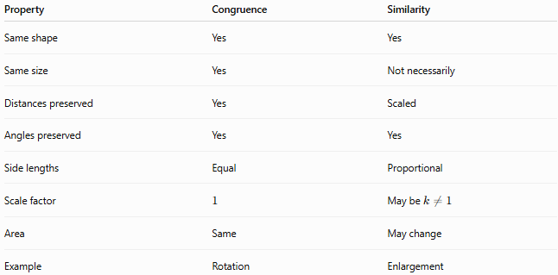
Property | Congruence | Similarity
Same shape | Yes | Yes
Same size | Yes | Not necessarily
Distances preserved | Yes | Scaled
Angles preserved | Yes | Yes
Side lengths | Equal | Proportional
Scale factor | $$1$$ | May be $k≠1$
Area | Same | May change
Example | Rotation | Enlargement
A similarity transformation can change size, whereas a congruence transformation cannot.

Congruence vs General Transformation
# Source: AI Source: Provided by: [Data Path: Persons Table -> ID Column: 1, Name_En Column: Motasem Essam] -> From: [ChatGPT] on [7/25/2026]
Not every geometric transformation is a congruence transformation.
For example:
Enlargement
$$\left(x , y\right)→\left(2 , x2y\right)$$
changes the size, so it is not a congruence transformation.
Congruence transformation
$$\left(x , y\right)→\left(x , +3y+4\right)$$
preserves all distances, so it is a congruence transformation.

Composition of Congruence Transformations
# Source: AI Source: Provided by: [Data Path: Persons Table -> ID Column: 1, Name_En Column: Motasem Essam] -> From: [ChatGPT] on [7/25/2026]
Two or more congruence transformations can be combined.
For example:
$$\text{Reflection}+\text{Translation}$$
produces a:
$$\boxed{\text{Glide Reflection}}$$
Similarly, combinations of rotations, reflections, and translations can produce another isometry.
The composition of congruence transformations is itself a congruence transformation.
$$\boxed{T_{2}∘T_{1}=\text{Congruence Transformation}}$$
provided $T_{1}$and $T_{2}$are both isometries.

Coordinate Representation
# Source: AI Source: Provided by: [Data Path: Persons Table -> ID Column: 1, Name_En Column: Motasem Essam] -> From: [ChatGPT] on [7/25/2026]
A general Euclidean isometry in the plane can be represented using a matrix and translation vector:
$$\boxed{x^{'}=Ax+b}$$
where $A$is an orthogonal matrix satisfying:
$$\boxed{A^{T}A=I}$$
This condition ensures that distances are preserved.
The determinant distinguishes orientation:
$$det⁡\left(A\right)=1$$
for orientation-preserving transformations such as rotations, and
$$det⁡\left(A\right)=-1$$
for orientation-reversing transformations such as reflections.

Important Properties
# Source: AI Source: Provided by: [Data Path: Persons Table -> ID Column: 1, Name_En Column: Motasem Essam] -> From: [ChatGPT] on [7/25/2026]
Distance
$$\boxed{PQ=P^{'}Q^{'}}$$
Angles
$$\boxed{m∠A=m∠A^{'}}$$
Perimeter
$$\boxed{P^{'}=P}$$
Area
$$\boxed{A^{'}=A}$$
Shape
$$\boxed{\text{Same shape}}$$
Size
$$\boxed{\text{Same size}}$$

Examples in Geometry
# Source: AI Source: Provided by: [Data Path: Persons Table -> ID Column: 1, Name_En Column: Motasem Essam] -> From: [ChatGPT] on [7/25/2026]
Congruence transformations are used when:
- moving a triangle without changing it,
- rotating a polygon,
- reflecting a figure,
- creating repeating patterns,
- proving two figures are congruent,
- studying symmetry,
- constructing geometric figures.

Classification Summary
# Source: AI Source: Provided by: [Data Path: Persons Table -> ID Column: 1, Name_En Column: Motasem Essam] -> From: [ChatGPT] on [7/25/2026]
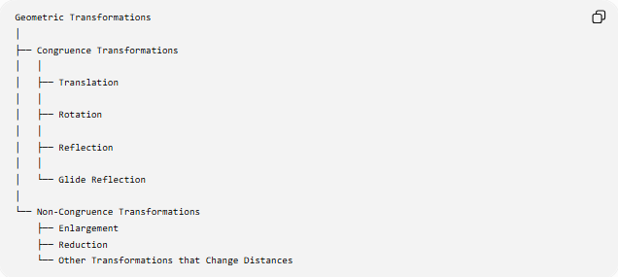
Geometric Transformations
│
├── Congruence Transformations
│ │
│ ├── Translation
│ │
│ ├── Rotation
│ │
│ ├── Reflection
│ │
│ └── Glide Reflection
│
└── Non-Congruence Transformations
├── Enlargement
├── Reduction
└── Other Transformations that Change Distances
By orientation:
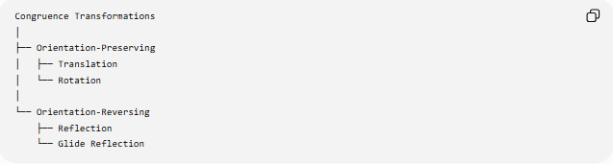
Congruence Transformations
│
├── Orientation-Preserving
│ ├── Translation
│ └── Rotation
│
└── Orientation-Reversing
├── Reflection
└── Glide Reflection

Key Points
# Source: AI Source: Provided by: [Data Path: Persons Table -> ID Column: 1, Name_En Column: Motasem Essam] -> From: [ChatGPT] on [7/25/2026]
- A Congruence Transformation preserves distance.
- It preserves shape and size.
- It preserves angle measures.
- It preserves perimeter and area.
- It is also called an isometry.
- The four fundamental plane congruence transformations are:
  - Translation
  - Rotation
  - Reflection
  - Glide Reflection
- Translation and rotation preserve orientation.
- Reflection and glide reflection reverse orientation.
- Congruent figures satisfy:
$$\boxed{S≅S^{'}}$$

Conclusion
# Source: AI Source: Provided by: [Data Path: Persons Table -> ID Column: 1, Name_En Column: Motasem Essam] -> From: [ChatGPT] on [7/25/2026]
A Congruence Transformation is a transformation that maps a geometric figure to another figure while preserving all distances and angle measures. Consequently, the original and transformed figures have exactly the same shape, size, perimeter, and area.
The fundamental congruence transformations are:
$$\boxed{\text{Translation, Rotation, Reflection, Glide Reflection}}$$
In Euclidean geometry, these transformations are isometries, making them the fundamental transformations used to establish and study congruent figures.

